# Document for which below notes are written:

Document: Hsiao, J.S. and Tang, C.Y., 1992, *An efficient algorithm for finding a maximum*

*weight 2-independent set on interval graphs*, Taiwan, K. Ikeda. Available at: < <https://drive.google.com/file/d/1aXZonqubYzj0eDBWC_fVRyWkNJbYm5XW/view> >.

# Instructions

Each group is required to present the research work discussed  
in the assigned paper as per the following content (10 minute+5 minute for dry run). The submission will be in the form of video using screen sharing where all partners will collaborate. You should read carefully the following requirement so that you do not miss anything required for good assessment. 

1. Description of the introduction of the domain necessary to understand the basic concept of the paper (6 marks).
2. Brief Discussion of the related work discussed by the authors ((3 marks)
3. What is the aim of the paper? What is the problem addressed in the paper? How the paper is different  
   from the previous work as claimed by the authors. (5 marks)
4. Details of the methodology adopted to solve the identified problem. (8 marks)
5. How the authors have provided the evidence to justify their claims. In this  
   section you can discuss the results provided in the paper. (8 marks)
6. Challenges that can be foreseen during the implementation of the paper. (5 marks)
7. Dry run of the technique using a simple input (15 marks)

Group work May be divided in the following way:

* Group member 1 , First two points (9) and a major role in Dry run(7) = 16
* Group member 2, 3rd and the 4th point (13)  and dry run (3) )(16)= 16
* Group member 3, 5th and 6th point (13 marks) and dry run (3) =16

Group work May be divided in the following way in case of 4 members (time 12 minutes)

* Group member 1 , First and 3rd point(6+5 )
* Group member 2, 2nd and the 5th point (3+8)
* Group member 3, 3rd and 4th point and dry run (3+8 marks)
* Group member 4,  Dry Run (11) 4 marks of the dry can be shared by other members by describing the input and explaining the structure of the code

# Terminologies

* **Interval graph**
* **Maximum Independent Set (MIS)**
* **Maximum Weighted Independent Set (MWIS)**
* **Maximum Weighted K Independent Set (MWKIS)**
* **Maximum Weighted 2 Independent Set (MW2IS)**

# Terminologies explained

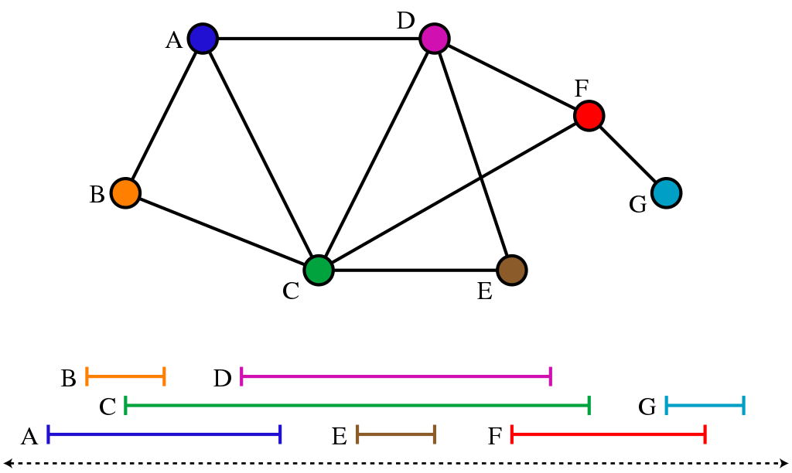

An **interval graph** is an undirected graph formed from a set of intervals on the *real line*, with a vertex for each interval and an edge between vertices whose intervals intersect. It is the intersection graph of the intervals. No two intervals share a common endpoint.

**Maximum Independent Set Problem (MIS):** To find maximum number of vertices that aren’t connected with each other with an edge:

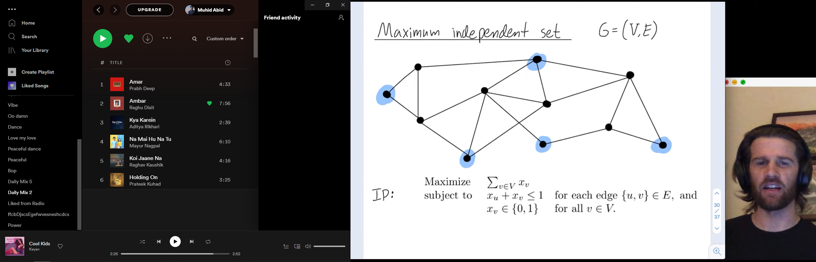

**Maximum Weight Independent Set Problem (MWIS):** Above problem but with weights.

**Maximum Weighted K-Independent sets (MWKIS):** MKIS problem on a graph **G** is to determine k disjoint independent sets **S1, S2,...,Sk** in G such that **S1 U S2 U ...Sk** is maximum. The MKIS problem is NP-complete for general graphs (Gavril and Yannakakis in Das, 2010).

**Maximum Weighted 2-Independent set problem (MW2IS):** M2IS is an MKIS problem as defined above. M2IS only includes 2 independent sets such that **S1 U S2** is maximum.

# Definitions from the document

* *Graph* **G** = (V, E) is an **interval graph** with *vertex* **V** and *edge* **E**
* *G* corresponds to *intervals* **I = {i1, i2, . . . , in}** and **ic = {ac, bc}** on a *real line* **R. ac** and **bc** are left and right endpoints respectively
* For an interval *ic*in Iweight of the interval is **wt(ic)**
* **Q** = 2-independent set
*  is the weight of 2-independent set
* For each independent set **S** of I, **r(S)** is the largest index of the intervals in *S*
* **X(c)** is a set of independent sets of *I*, such that for each independent set S in X(c), largest index, r(S), will be **c**.
* **In Section 2:**
  + I = {i1, i2, i3, . . . , in} is a set of weighted intervals
  + Denote **MWS(c)** for MWIS in *X(c)* and **x(c)** for weight of *MWS(c)*
  + MWIS of *I* will be max{x(c)|1<=c<=n} and is denoted by 
* **In Section 3:**
  + **2 independent set** denoted by **Q**, it composes of 2 disjoint sets S1 and S2   
    such that Q = S1 U S2 and S1 S2 = 0
  + **d(Q)** = (r(S1), r(S2))
  + **Y(k, j)** is a set of 2-independent sets of *I*. Where d(Q) = **(k, j)** and k!=j. In other words **k** = r(S1), **j** = r(S2)
  + **MWQ(k, j)** is an MW2IS in Y(k, j). **\*2 independent sets of the same data are in Y(k, j) and might have some overlapping intervals. We have to find 2 disjoint sets from Y(k, j)**
  + **µ(k, j)** is weight of MWQ(k, j) in Y(k, j). **\*which means there are multiple MWQs in Y(k,j) and we have to select the max from them.** In other words *wt*(MWQ(k, j)) = µ(k, j).
  + ***ѱ(I)*** is weight of MW2IS of I **\*this is our final answer. Maximum from all the µ(k, j)**

# Assumptions

* Each interval contains both its endpoints and that no two intervals share a common endpoint
* The sorted endpoints list is given and the intervals in I are indexed by increasing right endpoints, that is, b1 < b2 < . . . < bn.

# Theorems



In X(c), all Independent Sets have the highest index **c** so for MWS(c) the weight is **x(c)**.  
**wt(ic)** is the weight of the interval with the highest weight. It is highest because **c** is the *largest index*.  
Third expression in the equation means the weight, x(x), of a set with the highest weight after removing the largest interval (that is the one with index **c, ic = {ac,bc}**).

Theorem 2.1 in simpler words:

***Weight of MWS in a set of independent sets X(c)*** *=* ***weight of largest common interval, c, in all independent sets*** *+* ***weight of MWS in a set of independent sets obtained by removing ic from each independent set***



# Algorithms

## Linear time maximum weight independent set O(n)

Given a set of intervals:

**Variables**



**Based on Theorem 2.1:**

**Step 1 – Calculate weight of MWIS**

1. temp_max = 0
2. Every endpoint scanned from left to right
3. *If* scanned endpoint is left endpoint, ac: x(c) = wt(ic) + temp_max
4. *If* scanned endpoint is right endpoint, bc: *if* x(c) > temp_max: temp_max = x(c)
5. Weight of MWIS stored in temp_max = x(last interval)

**Step 2 – Derive MWIS (let it be Smax­)**

1. Put last interval (let it be ilast_interval) into Smax­
2. temp_max = temp_max – wt(ilast_interval)
3. search for interval ic with right endpoint smaller than the left endpoint of ilast_interval and x(c) = temp_max
4. put ic into Smax
5. ilast_interval = ic
6. repeat until all intervals checked

**Example:**

 

## Maximum Weight 2-Independent Set (Time: O(n2), Space: O(n2))

**Step 1 – Calculate µ(k, j)**

* temp_max = 0, µ(k, c) = 0
* Scan endpoints from left to right
* Initial temp_max = µ(k, 0) (temp max will have max µ(k, x))
* ***if*** is left endpoint and c < k: <do nothing>
* ***elif*** is left endpoint and c > k: by Theorem 3.3, µ(k, c) = wt(ic) + temp_max
* ***elif*** endpoint is one of ik: <do nothing>
* ***elif*** is right endpoint: ***if*** µ(k, c) > temp_max: temp_max = µ(k, c)

***else:*** <do nothing>

* Iterate **n** times for different values of **k** in increasing sequence

**Step 2 – Find MW2IS, Qmax:**

From above Step 1 we get this for set of intervals in Fig. 1:



1. Assume ***ѱ(I)*** to be the last calculated value (bottom corner in table) , µ(u,v). Where u=7 and v=8 in this case.
2. Set ***ѱ(I)*** = µ(u,v) and subtract wt(iu)+wt(iv) from ***ѱ(I)***
3. Add iu and iv into final MW2IS, **Qmax2**
4. Then iterate upward column-wise and check if µ(k,j) = ***ѱ(I)***
5. Add ik and ij into final MW2IS, **Qmax2**
6. if yes, repeat step 4 and 5 until no interval left

### MW2IS Algorithm



# Bibliography:

Explaining what a Maximum Set Interval Problem is: < <https://youtu.be/R79vlRyL2VY> >.

Das, K., 2010. An optimal algorithm to find maximum independent set and maximum 2-independent set on cactus graphs. *AMO-Advanced Modeling and Optimization*, *12*(2), pp.239-248.

Gavril, F. and Yannakakis, M., The maximum k-colorable subgraph problem for chordal graphs, Information Processing Letter, 24 (1987) 133-137.